Windows key → type cmd → Enter

Python library required to run the program or code in Python Idle

pip install pandas:
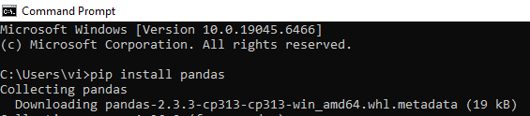

pip install scipy:
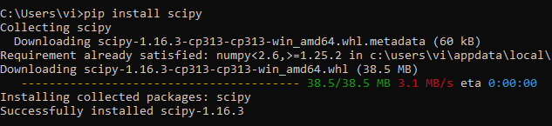

pip install matplotlib:
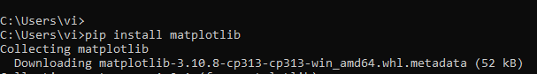

pip install networkx

pip install numpy
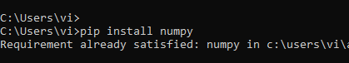

pip install pillow

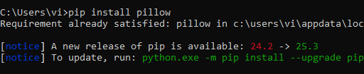

pip install pandas
pip install matplotlib
pip install networkx
pip install pillow
pip install numpy
pip install scipy

